ORTHO DRAWING RESTORE FROM BACKUP

- Restore-as-copy the plant with the old ortho that needs to be restored
- Open 2 sessions: a. The active model, b. The restored-as-copy model
- IN THE RESTORED-AS-COPY MODEL SESSION:
  - Go to Drawings and Reports task to find and verify the drawing to restore. Before continuing copy its name to clipboard:
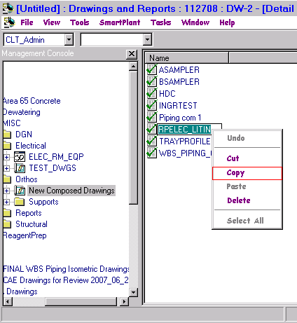
  - Change Task to Common and create a filter that captures the drawing to be restored as shown below. For Cliffside project a filter exists that can just be modified. It’s at: Plant Filters>Modeling Filters>DWG_RESTORE
  - Set this filter’s Object Type to:
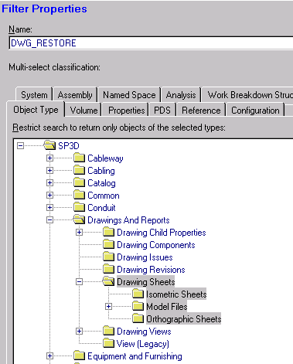
  - Set this filter’s Properties tab to the name of the drawing:
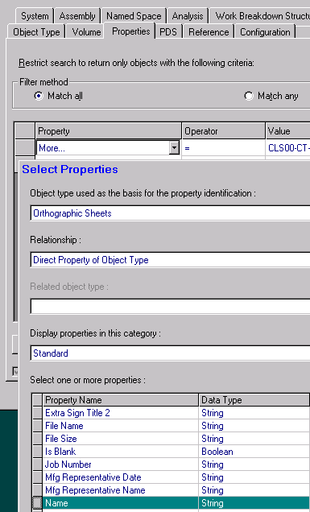
Intergraph recommends pasting in the value and then clicking the gray area below the properties rather than using tab or Enter in the
  - Value field:
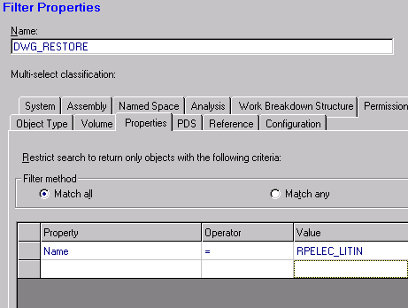
  - If restoring only one drawing, select OK to save this filter and skip to step 4
  - If restoring multiple drawings, select “Match any” button and proceed to the next step
  - Set the next Property field to “Name” and the Operator to “=”
  - Paste (or type) into the Value field the name of another drawing to restore
  - Repeat the last 2 steps for as many drawings as need to be restored
  - Once all drawings to restore are listed in the Properties tab, select OK to save this filter and continue to the next step
- Use the new filter (DWG_RESTORE in the example) to define your workspace in the restored-as-copy plant
- Go to the active plant’s open session in Common task and select Define Workspace
- Use the existing or create a DWG_RESTORE filter. This is different from the one above in that the properties tab will not be defined, only the Object Type tab will be defined as follows:
- OK this filter to be used by Define Workspace… You’ll notice update taking longer than what it took in the restored-as-copy plant. It’s because all drawings get initialized.
- For verification purposes, you can optionally go to Drawings and Reports task to review the location of the old drawing that is about to be restored with the backup copy:
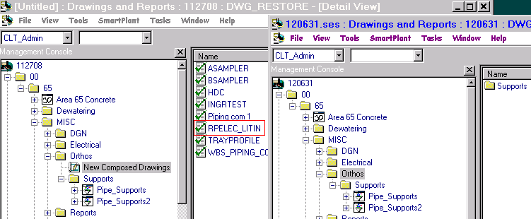
- In the active model session change task to Common
- In the restored-as-copy session also set the task to Common
- In the restored-as-copy session Use Tools>Select by Filter to locate the drawing restore filter just created, i.e. Plant Filters>Modeling Filters>DWG_RESTORE and OK
- That selected the drawing(s) to restore. Now select Edit>Copy to post this drawing(s) to the clipboard
- Go to the active model session and select Paste and Restore:
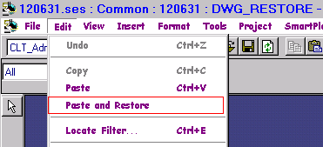
- -
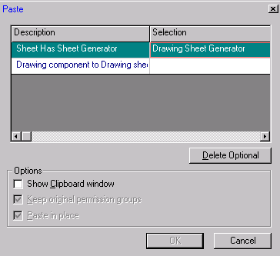
- If by mistake you select just regular Paste or CTL-V option, the OK button on the paste form will not activate. Using Paste and Restore will ensure the OK button is activated.
- Select OK to paste the drawing into the active plant. The following notification should appear:
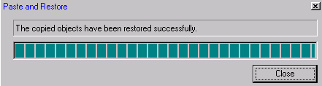
- Close this form
- In the active plant’s Drawings and Reports task verify that the drawing(s) has been restored
- IMPORTANT: This may be a bug, but if the restored drawing’s views are not re-associated to their corresponding 3D volume, the views will disappear the next time that Update is run
- Go into graphics and set up a 3D session workspace that includes the 3D Space Management volume(s) that correspond to the restored drawing(s)
- Use Tools>Open Drawing to open the restored drawing
- Select a view, then the associate command
- Select the 3D volume this view was originally associated with before the restore procedure, it should highlight in yellow. It’s ok to click the volume to unselect it, then click it again to reselect it
- Return to the Drawing Editor in 2D and select Save
- Repeat for all the views in the drawing, then save and exit
- Repeat for all other drawings restored.

